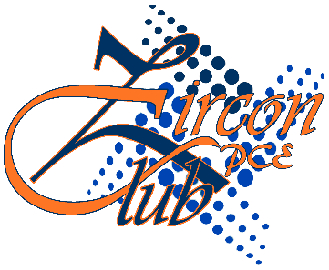

**Email – zircon.aadhar@poornima.org**

**ISI-6 RIICO Institutional Area, Sitapura, Jaipur-302022 (Rajasthan)**

**Poornima College of Engineering**

**Zircon Club**

**About**

Zircon Club which opened door for new ideas, exceeding all the boundaries of imagination. The club was first established in year 2010 at Poornima College of Engineering with a perception of aspiring students to gain practical knowledge and to transform innovative ideas into reality.

Although the concern of today’s scenario seems to be more inclined towards gaining theoretical knowledge but by each passing second and increase in technological advancement, the urge of having practical skills is boosting. And in order to quench this thirst of knowledge, the students initiated the club and has been driven by students themselves who leaves no stone unturned to orient the new corners.

Going with literal meaning of the word Zircon, a gemstone of many colours, the club un-rolls it’s hues beyond the boundaries of college campus. The members and the coordinators of this club impart tremendous participation in various tech fests held at many IIT’s and NIT’s. They have not just been the show-learners but many a times, were entitled as the Trend Setters.

Every year, Zircon Club organizes a tech fest called AADHAR for 1st year students and motivates them to shape millions of ideas, streaming through their brains. Zircon Club conduct sessions and workshops on technologies and many more diversified areas such as Aero-Modelling, Coding, Web Designing, Embedded Systems, Robotics, civil-modelling etc.. In year 2014 “Aero Modelling Workshops” was organized by zircon club in collaboration with “BITS PILANI” and “Embedded System Workshop” was taken by club members for PGC students.

**Mission**

The prime concern of the club is to push forward what’s possible as a student organisation, both in terms of technical accomplishments and educational value. That is why we welcome students from all backgrounds and experiences, and offer them real hands on experience in programming, aero-modelling, circuitry, robotics and leading a team. Our ultimate goal is to open the possibility of becoming a innovator to anyone. Apart from participating in events, workshops and competitions, members of Zircon Club bear a responsibility to pass on their technical knowledge to all those interested people who are in the quest of searching for technical stuff.

**Achievements**

* Member of Zircon Club have won prizes in various events of IITs and NITs.
* Every year Zircon Club guides the students of first year in making their projects.

**Objectives of the Club**

1. To explain the concepts of programming, aero-modelling, civil-modelling, circuitry and robotics in a practical way and help them to gain knowledge.
2. To provide a platform for the students to give a shape to their innovative ideas.
3. To expose the students to the latest technological advancements.
4. To provide the students with thought provoking questions & makes them to think about it.
5. To form a discussion boards on latest trends of technology which indeed improve their communication skills
6. To provide a hands-on training for students.
7. To provide a virtual bridge between the present global industries and the students.

**Future Plan**

* We will ask students about their area of interest and help them to develop their ideas.
* We will update them with each and every technical advancement happening around the world.
* We will take up mini projects and make them to work on it.
* Through our contacts we will invite the officials of several global industries to have seminars.
* We will follow the methodology of outcome based participation in Technical events of various IITs and NITs in upcoming years.